***BRISINGA JOINT EXAMS***

***2024 SERIES***

**AGRICULTURE**

**PAPER 2**

**SECTION A (30 MKS)**

1. Name four rabbit breeds reared in Kenya. (2 mks)

………………………………………………………………………………………………………………………………………………………………………………………………………………

……………………………………………………………..……………………………………………………………………………………………………………………………………………………………………………………………………………..………………………………………

1. What is cropping in respect with fish farming (1 mk)

……………………………………………………………..……………………………………………………………………………………………………………………………………………………………………………………………………………..………………………………………

1. State four practices carried out on fencing posts. (2 mks)

………………………………………………………………………………………………………

……………………………………………………………………………………………………………………………………………………………………..……………………………………………………………………………………………………………………………………………………………………………………………………………..………………………………………

1. Name two types of roughage. (1 mk)

……………………………………………………………..……………………………………………………………………………………………………………………………………………………………………………………………………………..………………………………………

1. Differentiate between mothering ability and prolificacy (1 mks)

………………………………………………………………………………………………………

………………………………………………………………………………………………………

1. Give four disadvantages of inbreeding in livestock (2 mks)

………………………………………………………………………………………………………

……………………………………………………………..……………………………………………………………………………………………………………………………………………………………………………………………………………..……………………………………………………………………………………………………..………………………………………

1. Name one nutritional deficiency for each of the following livestock diseases.
2. Milk fever ( ½ mk)

……………………………………………………………………………………………………………………………………………………………………..………………………………………

1. Bloat ( ½ mk)

………………………………………………………………………………………………………

………………………………………………………………………………………………………

1. Differentiate between drift and pen lambing. (2 mks)

……………………………………………………………..……………………………………………………………………………………………………………………………………………………………………………………………………………..………………………………………

1. State four features on the animal which may predispose it to livestock diseases.

(2 mks)

……………………………………………………………..……………………………………………………………………………………………………………………………………………………………………………………………………………..………………………………………………………………………………………………………………………………………………

………………………………………………………………………………………………………

1. outline four features that enable the Camel to survive in arid areas. (2 mks)

………………………………………………………………………………………………………

……………………………………………………………..……………………………………………………………………………………………………………………………………………………………………………………………………………..……………………………………………………………………………………………………..………………………………………

1. State four non-chemical methods of controlling ticks in cattle. (2 mks)

……………………………………………………………………………………………………………………………………………………………………..………………………………………………………………………………………………………………………………………………

………………………………………………………………………………………………………………………………………………………………………………………………………………

1. Give two reasons for hoof trimming in body of animals. (1 ½ mks)

………………………………………………………………………………………………………………………………………………………………………………………………………………

………………………………………………………………………………………………………

1. State three functions of water in the body of animals (1 ½ mks)

………………………………………………………………………………………………………………………………………………………………………………………………………………………………………………………………………………………………………………………………………………………………………………………………………………………………

1. Give four factors that affect milk composition. (2 mks)

………………………………………………………………………………………………………………………………………………………………………………………………………………………………………………………………………………………………………………………………………………………………………………………………………………………………………………………………………………………………………………………………………

1. a) Name the goat breed which is brown in colour with white strips running down the face to the nose ( ½ mk)

………………………………………………………………………………………………………………………………………………………………………………………………………………

1. State four rearing practices that necessitate handling of piglets. (2 mks)

………………………………………………………………………………………………………………………………………………………………………………………………………………………………………………………………………………………………………………………

………………………………………………………………………………………………………………………………………………………………………………………………………………

1. State four maintenance practices carried out on a fish pond. (2 mks)

………………………………………………………………………………………………………………………………………………………………………………………………………………………………………………………………………………………………………………………………………………………………………………………………………………………………………………………………………………………………………………………………………

1. Outline four merits of an embryo transplant when breeding livestock. (2 mks)

………………………………………………………………………………………………………………………………………………………………………………………………………………………………………………………………………………………………………………………………………………………………………………………………………………………………………………………………………………………………………………………………………

1. Give two livestock diseases controlled through artificial insemination. (1 mk)

………………………………………………………………………………………………………………………………………………………………………………………………………………………………………………………………………………………………………………………

**SECTION B (20 MKS)**

**Answer all questions in this section.**

1. The diagram below represents a livestock parasite. Use it to answer the questions that follow.

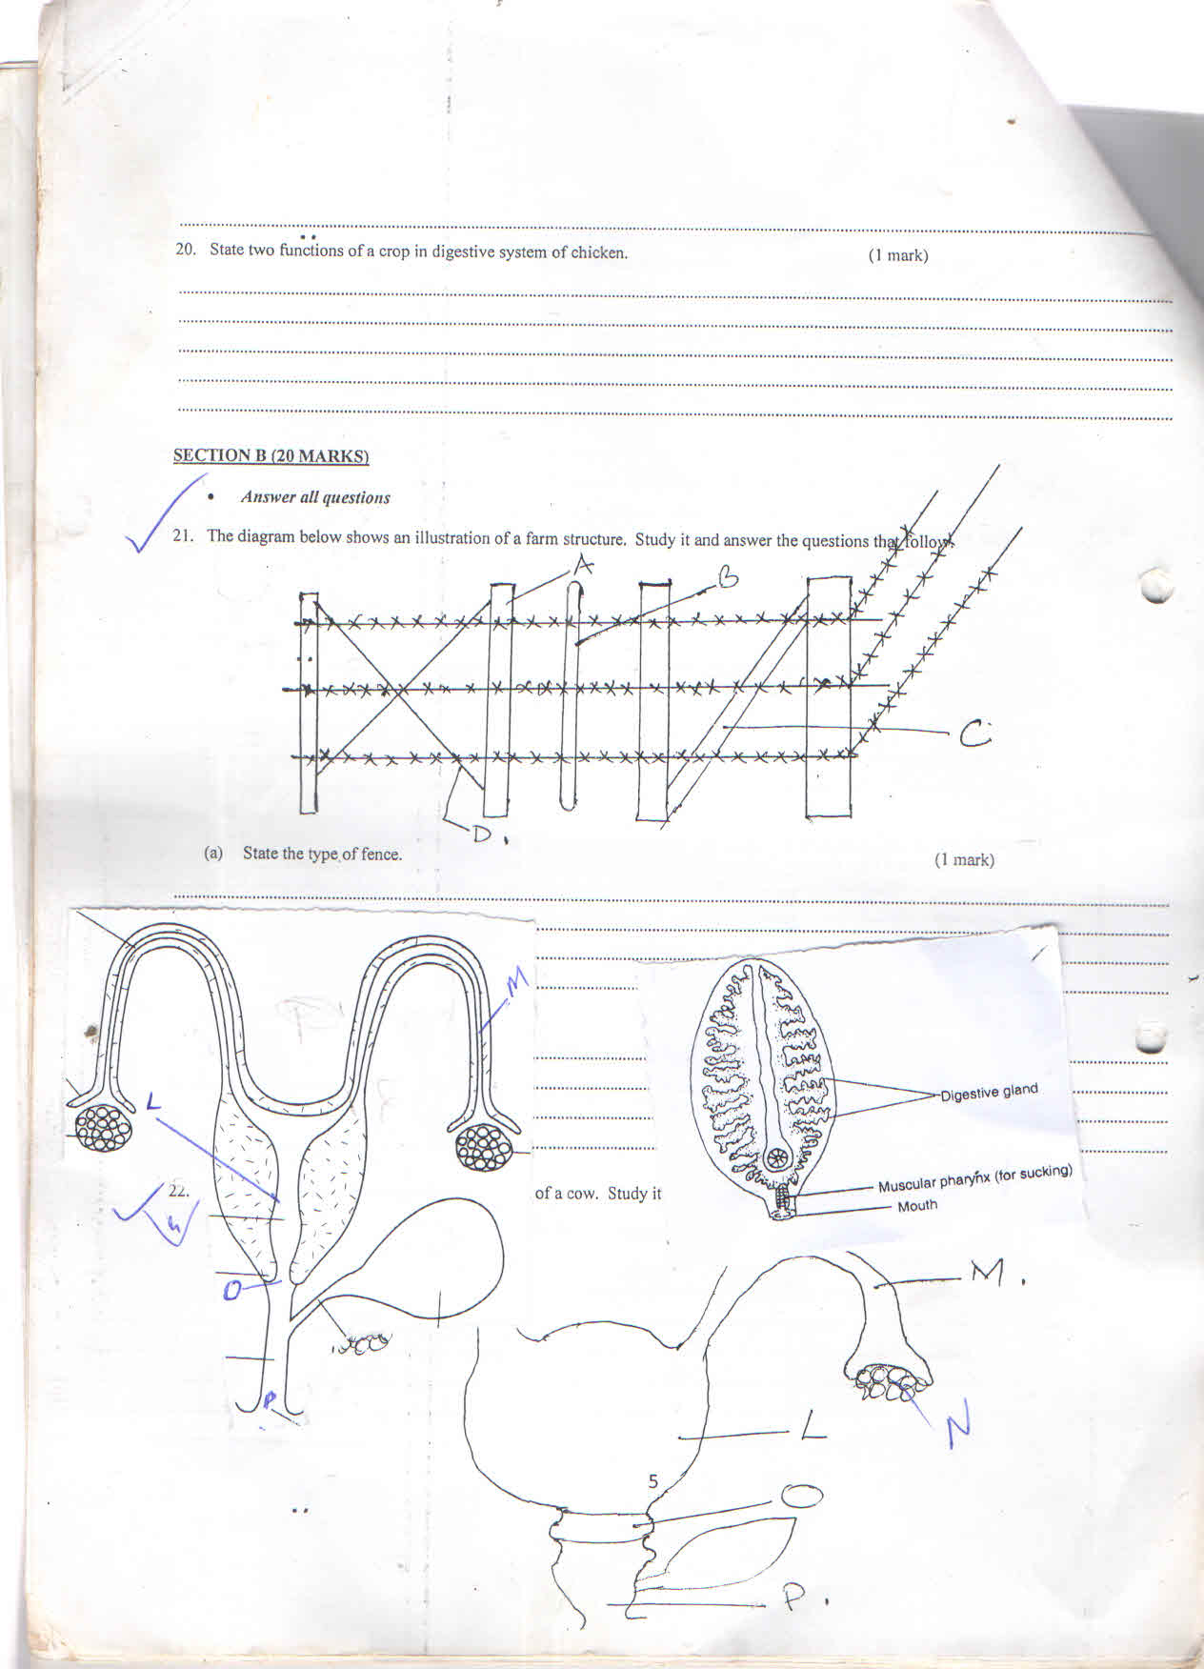

1. Identify the parasite (1 mk)

………………………………………………………………………………………………………

……………………………………………………………..………………………………………

1. Which part of the animal’s body is affected by above parasite (1 mk)

……………………………………………………………………………………………………………………………………………………………………..………………………………………

1. State three symptoms that may be observed (3 mks)

……………………………………………………………..……………………………………………………………………………………………………………………………………………………………………………………………………………..………………………………………

……………………………………………………………………………………………………..

1. The diagrams below represent some farm tools and equipment. Study them and answer the questions that follow.

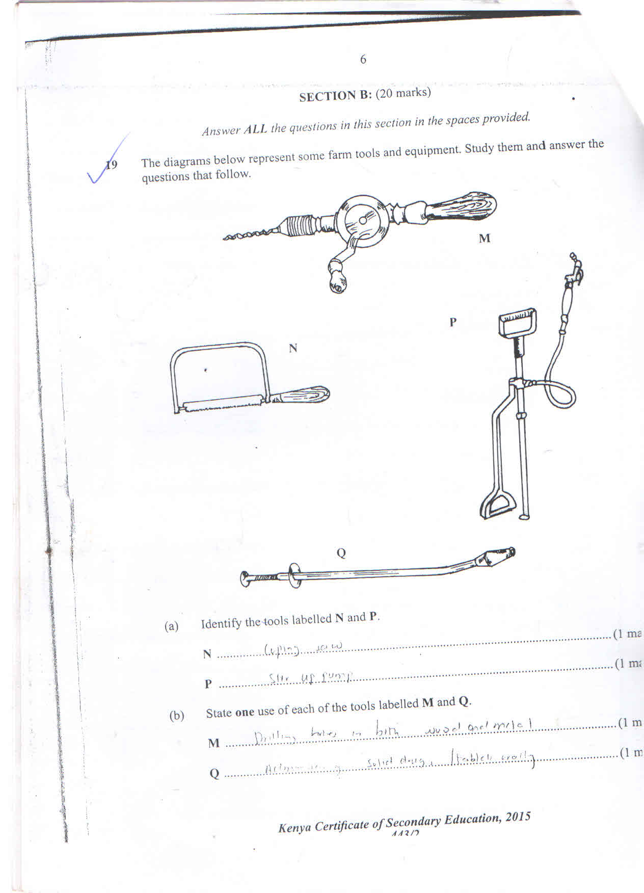

1. Identify the tools labelled N and P

N: ………………………………………………………………….………………(1 mk)

P: ……………………………………………………………………………………(1 mk)

1. State one use of each of the tools labelled M and Q

M: …………………………………………………………………………………(1 mk)

Q: …………………………………………………………………………………(1 mk)

1. Explain one maintenance practice carried out on the equipment labelled P.(1 mk)

……………………………………………………………………………………………………………………………………………………………………..………………………………………

1. The diagram below shows reproductive system of a cow. Study it and answer the questions that follow.



1. Name the parts labelled. (2 mks)

L: ………………………………………………………………………………………………….

M: ………………………………………………………………………………………………..

O: ………………………………………………………………………………………………..

P: ………………………………………………………………………………………………..

1. State the functions of parts labelled M and L (2 mks)

……………………………………………………………..……………………………………………………………………………………………………………………………………………………………………………………………………………..………………………………………

1. State any advantage of inbreeding livestock production (1 mk)

………………………………………………………………………………………………………

………………………………………………………………………………………………………

1. The diagram below shows an illustration of a farm structure.



1. State the type of fence (1mk)

………………………………………………………………………………………………………

……………………………………………………………..………………………………………

1. Name the parts labelled (4 mks)

A: ………………………………………………………………………………………….

B: …………………………………………………………………………………………...

C: …………………………………………………………………………………………..

D: …………………………………………………………………………………………..

**SECTION C (40 MKS)**

**Answer any two questions from this section in spaces provided after question 25 .**

1. a) Explain five roles of livestock farming in the economic development of Kenya.
2. mks)

b) Briefly explain the functions of worker bee in a bee colony. (5 mks)

c) State five harmful effects of lice in pigs. (5 mks)

1. a) State five signs of external parasite infestation in livestock. (5 mks)

b) Explain five factors that should be considered when siting a farm store. (5 mks)

c) Describe the cycle of a four stroke petrol engine (10 mks)

1. a) Describe ten characteristics of a good layer. (10 mks)

b) Discuss new castle under the following subheadings.

i. Symptoms of attack. (5 mks)

ii. Control measures. (5 mks)

……………………………………………………………………………………………………………………………………………………………………..……………………………………………………………………………………………………..……………………………………………………………………………………………………………………………………………………………………………………………………………..………………………………………………………………………………………………………………………………………………

……………………………………………………………………………………………………………………………………………………………………..……………………………………………………………………………………………………………………………………………………………………………………………………………..……………………………………………………………………………………………………..……………………………………………………………………………………………………………………………………………………………………………………………………………..………………………………………………………………………………………………………………………………………………

………………………………………………………………………………………………………………………………………………………………………………………………………………

……………………………………………………………..……………………………………………………………………………………………………………………………………………………………………………………………………………..……………………………………………………………………………………………………..……………………………………………………………………………………………………………………………………………………………………………………………………………..………………………………………………………………………………………………………………………………………………

……………………………………………………………………………………………………………………………………………………………………..……………………………………………………………………………………………………………………………………………………………………………………………………………..……………………………………………………………………………………………………..……………………………………………………………………………………………………………………………………………………………………………………………………………..………………………………………………………………………………………………………………………………………………

………………………………………………………………………………………………………

………………………………………………………………………………………………………

……………………………………………………………..……………………………………………………………………………………………………………………………………………………………………………………………………………..……………………………………………………………………………………………………..……………………………………………………………………………………………………………………………………………………………………………………………………………..………………………………………………………………………………………………………………………………………………

……………………………………………………………………………………………………………………………………………………………………..……………………………………………………………………………………………………………………………………………………………………………………………………………..……………………………………………………………………………………………………..……………………………………………………………………………………………………………………………………………………………………………………………………………..………………………………………………………………………………………………………………………………………………

………………………………………………………………………………………………………

………………………………………………………………………………………………………

……………………………………………………………..……………………………………………………………………………………………………………………………………………………………………………………………………………..……………………………………………………………………………………………………..……………………………………………………………………………………………………………………………………………………………………………………………………………..………………………………………………………………………………………………………………………………………………

……………………………………………………………………………………………………………………………………………………………………..……………………………………………………………………………………………………………………………………………………………………………………………………………..……………………………………………………………………………………………………..……………………………………………………………………………………………………………………………………………………………………………………………………………..………………………………………………………………………………………………………………………………………………

………………………………………………………………………………………………………

………………………………………………………………………………………………………

……………………………………………………………..……………………………………………………………………………………………………………………………………………………………………………………………………………..……………………………………………………………………………………………………..……………………………………………………………………………………………………………………………………………………………………………………………………………..………………………………………………………………………………………………………………………………………………

……………………………………………………………………………………………………………………………………………………………………..……………………………………………………………………………………………………………………………………………………………………………………………………………..……………………………………………………………………………………………………..……………………………………………………………………………………………………………………………………………………………………………………………………………..………………………………………………………………………………………………………………………………………………

………………………………………………………………………………………………………

……………………………………………………………..………………………………………………………………………………………………………………………………………………

**THIS IS THE LAST PRINTED PAGE.**